Evidence of Insurance
Policy Holder : | Paintball UK Ltd t/as Campaign Paintball
Correspondence  Address : | Old Lane  Cobham  KT11 1NH
Business Description : | Paintball, Laser and Airsoft Operator including mobile/off site events
Public, Products & Employers Liability
Period of Cover : | 8th January 2016 |  |  | to : | 7th January 2017
Limit of Indemnity : | Public Liability - any one occurrence |  |  |  |  | £5,000,000
 | Products Liability - any one occurrence and in aggregate in the period of insurance |  |  |  |  | £5,000,000
 | Employers Liability - any one occurrence |  |  |  |  | £10,000,000
Insurer : | Hiscox Insurance Company Ltd
Policy No : | HU PI6 16375787
Indemnity to Principal: | Yes
NB. This information is based on the insurance arrangements at the time of writing, and alterations may be made during the period of cover. Any expiry date shown represents the normal expiry date of the policy. In some circumstances, such as non-payment of premiums due, cancellation could occur before the normal expiry date and we would be pleased to confirm the current position upon request. Please Quote Client Ref: 4223979
SIGNED as Agent of the Insurer
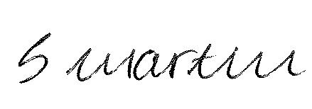  Steve Martin  Chartered Insurance Broker  Account Handler |  | Date: | 15th January 2016

